WEEK 4-SPRING REST-HANDS ON-EXERCISES
_____________________________________________________________________
- Spring Rest Hands On

1.Create a Spring Web Project using Maven
1.Visited https://start.spring.io
2. Set “Group” as com.cognizant
3. Set “Artifact” as spring-learn
4. Selected the following dependencies:
- Spring Boot DevTools
- Spring Web
5. Clicked “Generate” to download the ZIP file
6. Extracted the ZIP file to Eclipse workspace.
7. Opened Command Prompt in the project folder and ran the Maven build:
Command:
mvn clean package -Dhttp.proxyHost=proxy.cognizant.com -Dhttp.proxyPort=6050 -Dhttps.proxyHost=proxy.cognizant.com -Dhttps.proxyPort=6050 -Dhttp.proxyUser=6137524
8.Opened Eclipse → File > Import > Maven > Existing Maven Projects
* Selected the extracted project folder.
* Project appeared in Project Explorer.
9. Modified SpringLearnApplication.java.
SpringLearnApplication.java
package com.cognizant.spring_learn;
import org.slf4j.Logger;
import org.slf4j.LoggerFactory;
import org.springframework.boot.SpringApplication;
import org.springframework.boot.autoconfigure.SpringBootApplication;

@SpringBootApplication
public class SpringLearnApplication {
private static final Logger LOGGER = LoggerFactory.getLogger(SpringLearnApplication.class);
public static void main(String[] args) {
LOGGER.info("START");
SpringApplication.run(SpringLearnApplication.class, args);
LOGGER.info("END");
}
}
10. Right-clicked SpringLearnApplication.java → Run As > Java Application.

OUTPUT:
Console log showing START and END messages from SpringLearnApplication.

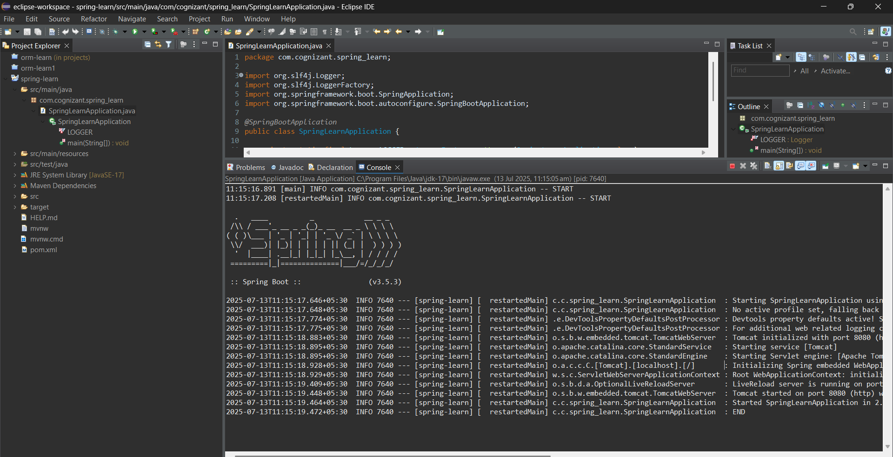

Pom.xml
The Dependency Hierarchy tab listing all compile-time and test-time dependencies such as spring-boot-starter-web, spring-boot-devtools, slf4j, jackson, etc.

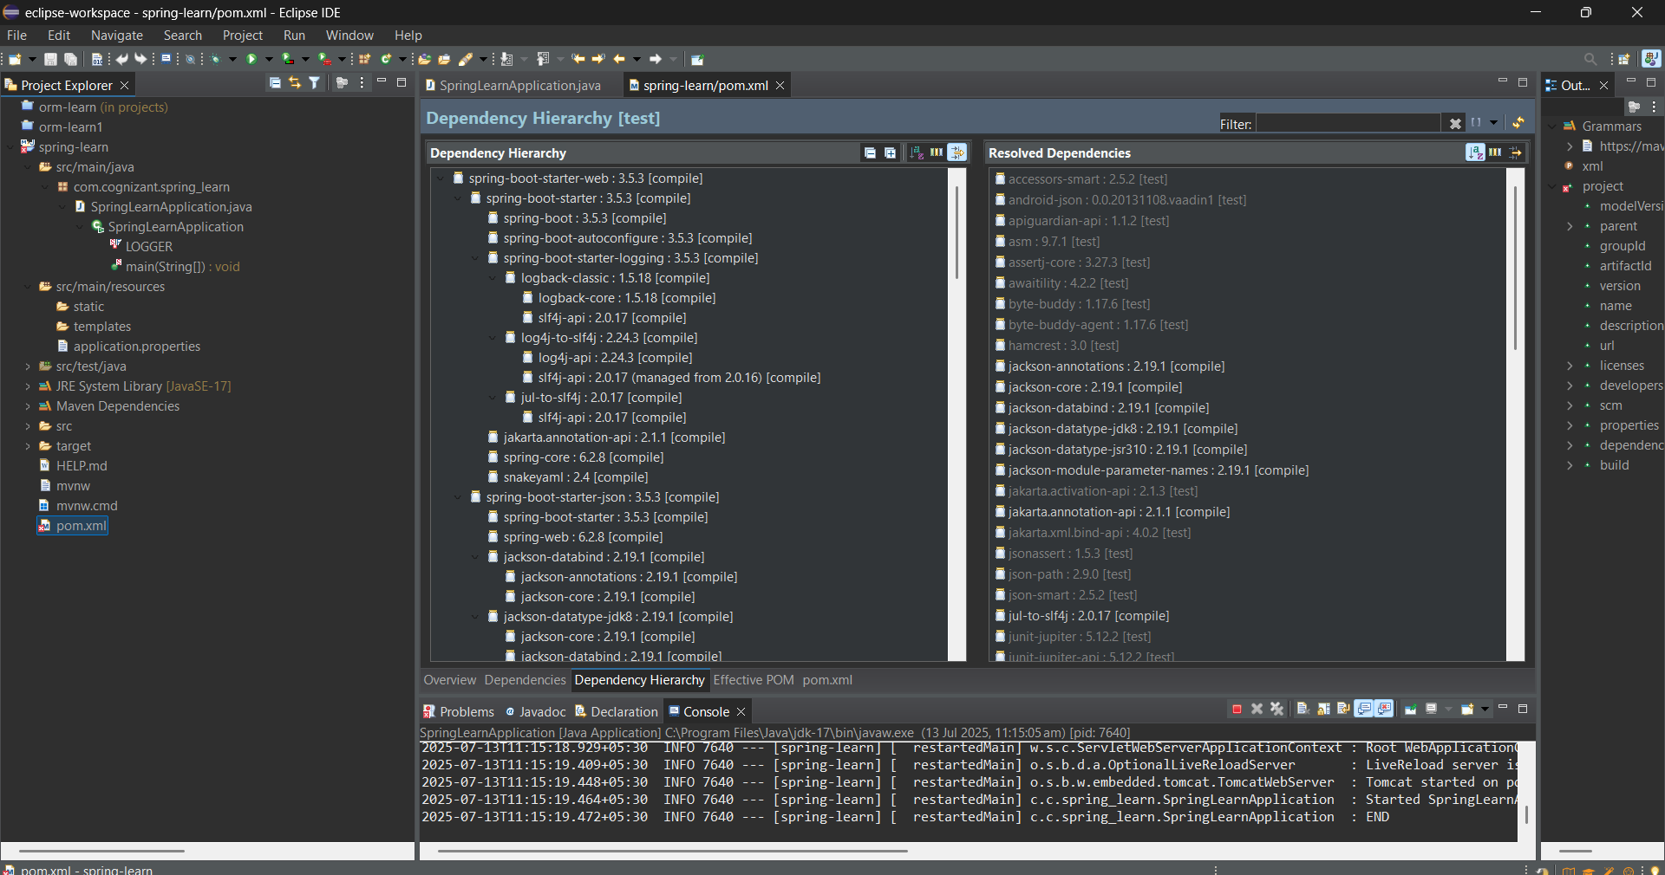
1.Spring Rest hands On
- Spring Core – Load Country from Spring Configuration XML

Steps to implement:

Pick any one of your choice country to configure in Spring XML configuration named country.xml.
Create a bean tag in spring configuration for country and set the property and values.

Country.xml
<?xml version="1.0" encoding="UTF-8"?>
<beans xmlns="http://www.springframework.org/schema/beans"
xmlns:xsi="http://www.w3.org/2001/XMLSchema-instance"
xsi:schemaLocation="
http://www.springframework.org/schema/beans
http://www.springframework.org/schema/beans/spring-beans.xsd">

<bean id="country" class="com.cognizant.springlearn.Country">
<property name="code" value="IN" />
<property name="name" value="India" />
</bean>
</beans>

Create Country class with following aspects:
→Instance variables for code and name
→Implement empty parameter constructor with inclusion of debug log within the constructor with log message as “Inside Country Constructor.”
→Generate getters and setters with inclusion of debug with relevant message within each setter and getter method.
→Generate toString() method
Country.java
package com.cognizant.springlearn;
import org.slf4j.Logger;
import org.slf4j.LoggerFactory;
public class Country {
private static final Logger LOGGER = LoggerFactory.getLogger(Country.class);
private String code;
private String name;
public Country() {
LOGGER.debug("Inside Country Constructor.");}
public String getCode() {
LOGGER.debug("Getting code: {}", code);
return code;
}
public void setCode(String code) {
LOGGER.debug("Setting code: {}", code);
this.code = code;
}
public String getName() {
LOGGER.debug("Getting name: {}", name);
return name;
}
public void setName(String name) {
LOGGER.debug("Setting name: {}", name);
this.name = name;
}
@Override
public String toString() {
return "Country [code=" + code + ", name=" + name + "]";
}
}
Create a method displayCountry() in SpringLearnApplication.java, which will read the country bean from spring configuration file and display the country details.
Invoke displayCountry() method in main() method of SpringLearnApplication.java.

SpringLearnApplication.java
package com.cognizant.springlearn;
import org.slf4j.Logger;
import org.slf4j.LoggerFactory;
import org.springframework.context.ApplicationContext;
Import org.springframework.context.support.ClassPathXmlApplicationContext;
public class SpringLearnApplication {
private static final Logger LOGGER = LoggerFactory.getLogger(SpringLearnApplication.class);
public static void main(String[] args) {
LOGGER.info("START");
displayCountry();
LOGGER.info("END");
}
public static void displayCountry() {
ApplicationContext context = new ClassPathXmlApplicationContext("country.xml");
Country country = context.getBean("country", Country.class);
LOGGER.debug("Country : {}", country);
}
}

Execute main() method and check the logs to find out which constructors and methods were invoked.
OUTPUT:
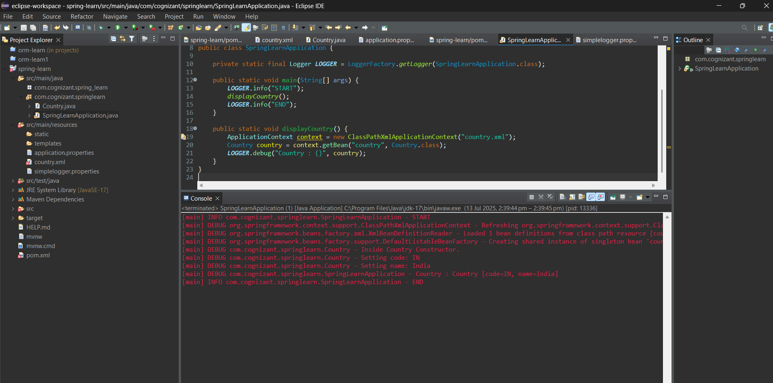
2.Spring Rest hands On
Hello World RESTful Web Service
Method: GET
URL: /hello
Controller: com.cognizant.spring-learn.controller.HelloController
Method Signature: public String sayHello()
Method Implementation: return hard coded string "Hello World!!"
Sample Request: http://localhost:8083/hello
Sample Response: Hello World!!

HelloController.java
package com.cognizant.springlearn.controller;
import org.slf4j.Logger;
import org.slf4j.LoggerFactory;
import org.springframework.web.bind.annotation.GetMapping;
import org.springframework.web.bind.annotation.RestController;
@RestController
public class HelloController {
private static final Logger LOGGER = LoggerFactory.getLogger(HelloController.class);
@GetMapping("/hello")
public String sayHello() {
LOGGER.info("START - sayHello()");
String message = "Hello World!!";
LOGGER.info("END - sayHello()");
return message;
}
}

OUTPUT:
Console log:
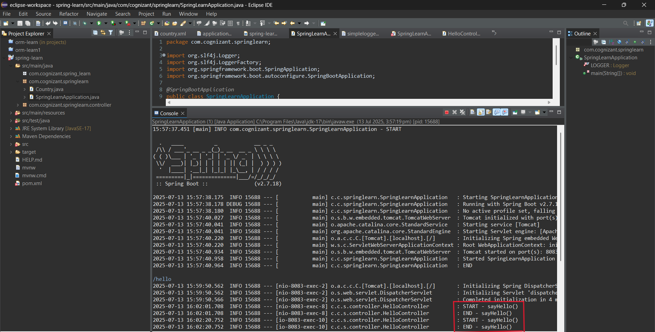

Chrome Browser:

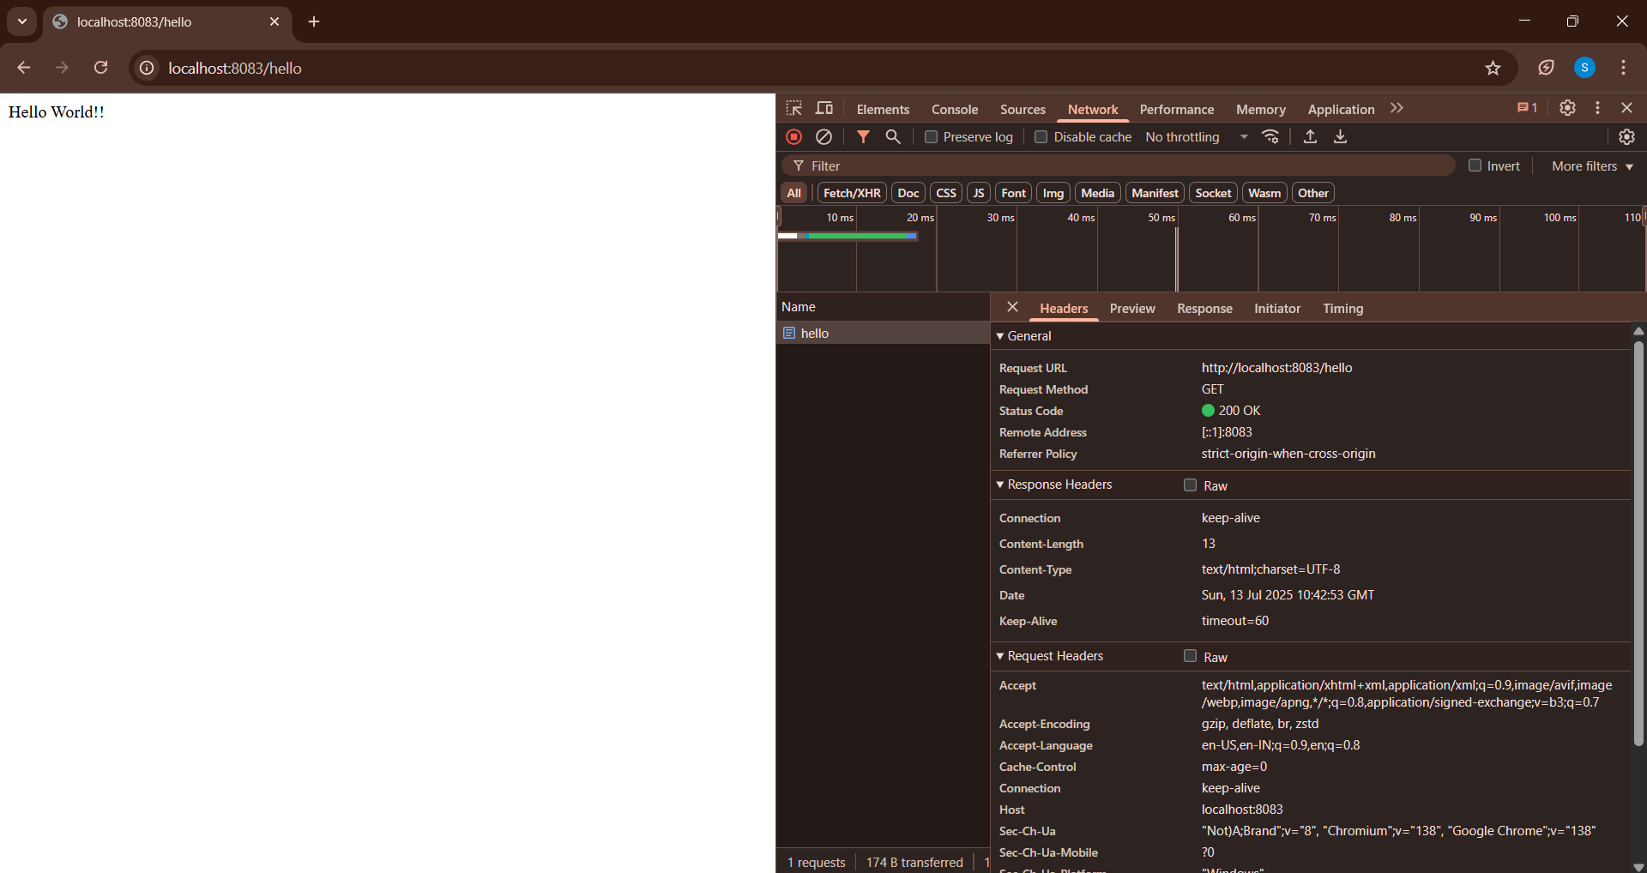

Postman:
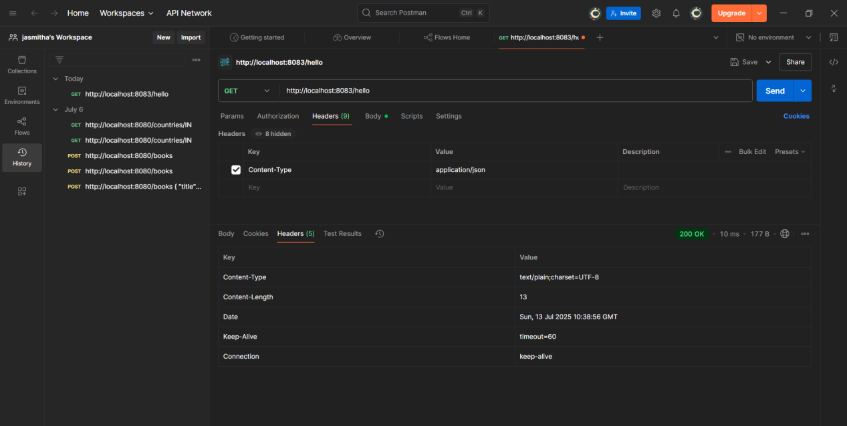

2.Spring Rest hands On
REST - Country Web Service
Write a REST service that returns India country details in the earlier created spring learn application.
URL: /country
Controller: com.cognizant.spring-learn.controller.CountryController
Method Annotation: @RequestMapping
Method Name: getCountryIndia()
Method Implementation: Load India bean from spring xml configuration and return
Sample Request: http://localhost:8083/country
Sample Response:

{
"code": "IN",
"name": "India"
}

What happens in the controller method?
The controller method is mapped to the /country URL.
When this URL is accessed, it loads the Country bean from the country.
xml file using Spring's application context and returns it.
Spring Boot then automatically converts the Java object into a JSON response and sends it back to the client.

How the bean is converted into JSON reponse?
When a method in a @RestController returns a Java object like Country, Spring uses Jackson's ObjectMapper to convert it into JSON automatically.
So, this Java object:
Country country = new Country("IN", "India");
It gets returned as: json
{
"code": "IN",
"name": "India"
}

OUTPUT:

Chrome browser:
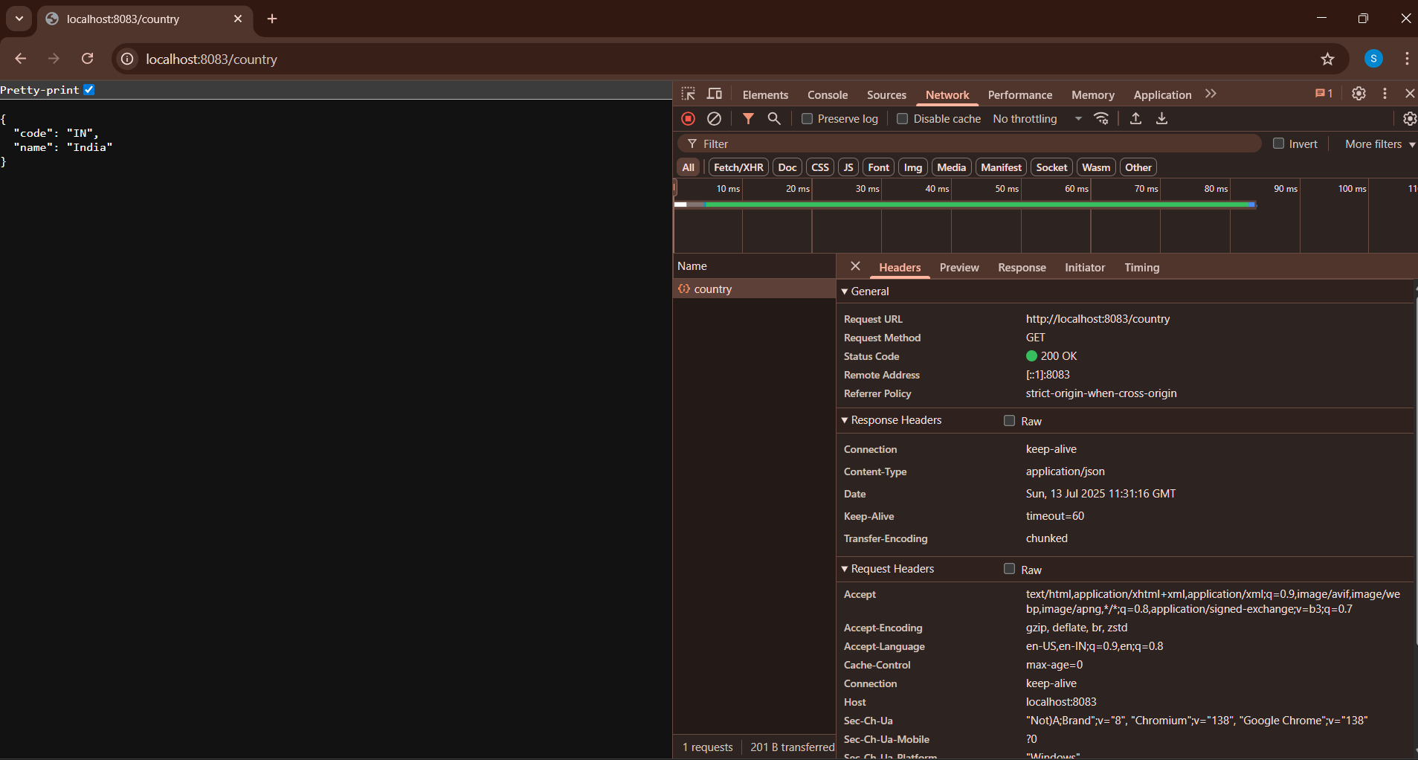

Postman:

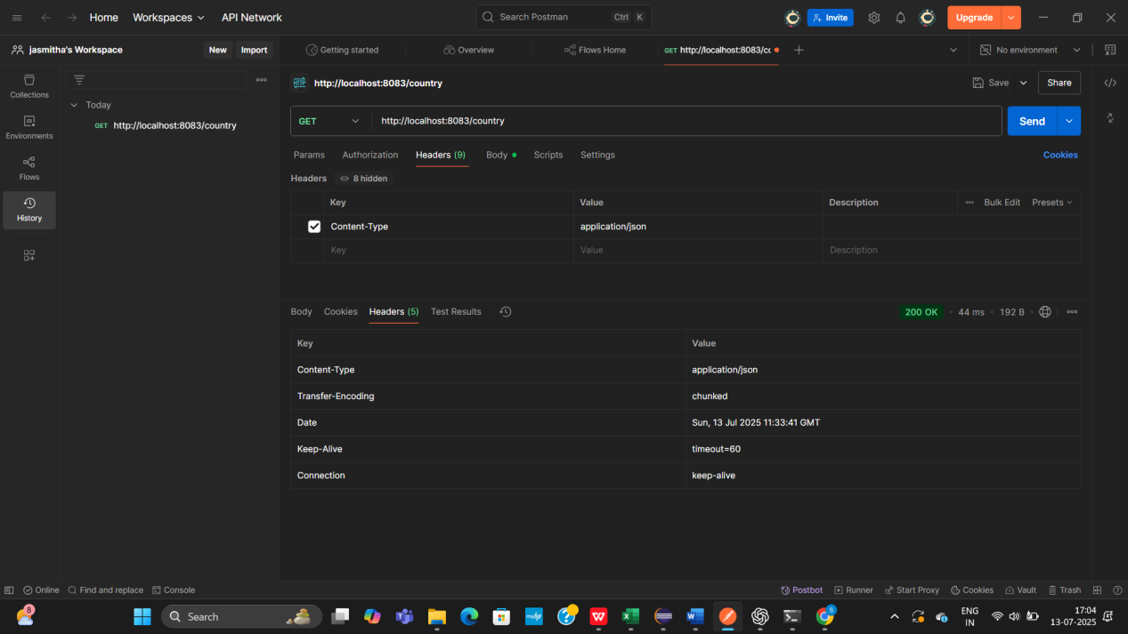

Console:
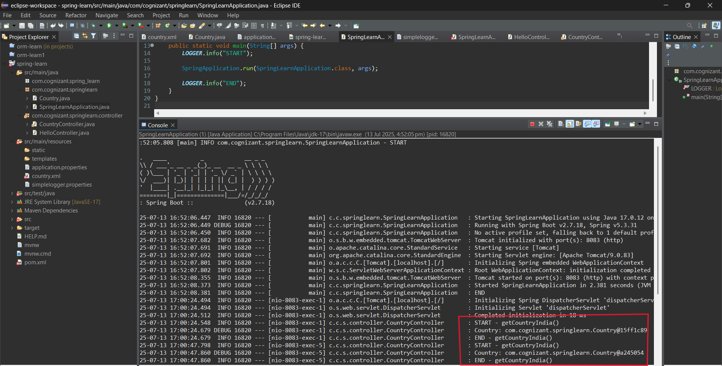
2.Spring Rest hands On
REST - Get country based on country code
Write a REST service that returns a specific country based on country code. The country code should be case insensitive.
Controller: com.cognizant.spring-learn.controller.CountryController
Method Annotation: @GetMapping("/countries/{code}")
Method Name: getCountry(String code)
Method Implemetation: Invoke countryService.getCountry(code)
Service Method: com.cognizant.spring-learn.service.CountryService.getCountry(String code)
Service Method Implementation:
•Get the country code using @PathVariable
•Get country list from country.xml
•Iterate through the country list
•Make a case insensitive matching of country code and return the country.
•Lambda expression can also be used instead of iterating the country list
Sample Request: http://localhost:8083/country/in
Sample Response:
{
"code": "IN",
"name": "India"
}

OUTPUT:

